Philippines: Recent Economic Developments and Outlook

# GDP growth in 2019 slowed down

GDP growth slowed down from 6.3% in 2018 to 6.0% in 2019. On the demand side, private consumption, accounting for 73.2% of GDP, contributed the most with 4.3 percentage points (pp). Government expenditure gave 1.2pp. Gross capital formation shared 0.7pp. On the other hand, net exports subtracted 0.1pp from growth. On the supply side, services, accounting for 61.0% of GDP, contributed the most with 4.5pp. Industry (including construction) added 1.4pp. Agriculture added 0.1pp.

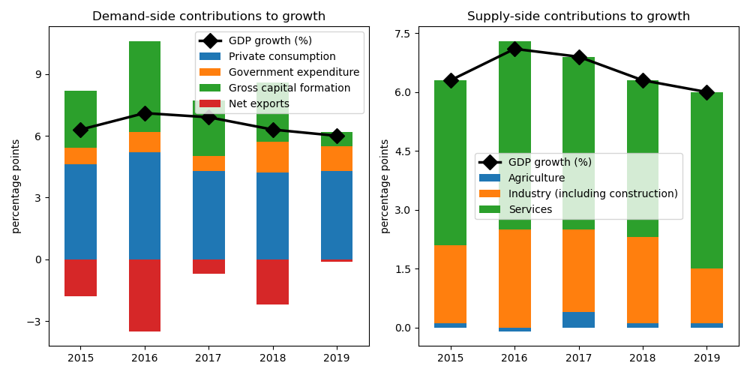

## Net exports achieved largest gain on the demand side

Net exports increased by the biggest margin at 10.4% annual growth. Government expenditure picked up by 9.6%. Private consumption increased by 5.9%. Gross capital formation increased by 2.5%.

## On the supply side, growth in services accelerated the fastest

Services increased by the largest edge at 7.5% annual growth. Industry (including construction) jumped by 4.7%. Agriculture jumped by 1.2%.

## Unemployment declined; inflation improved

Unemployment rate declined from 2.3% in 2018 to 2.2% in 2019. Consequently, inflation improved from 5.2% to 2.5%. At the end of the year, the central bank set the policy rate at 3.0%.

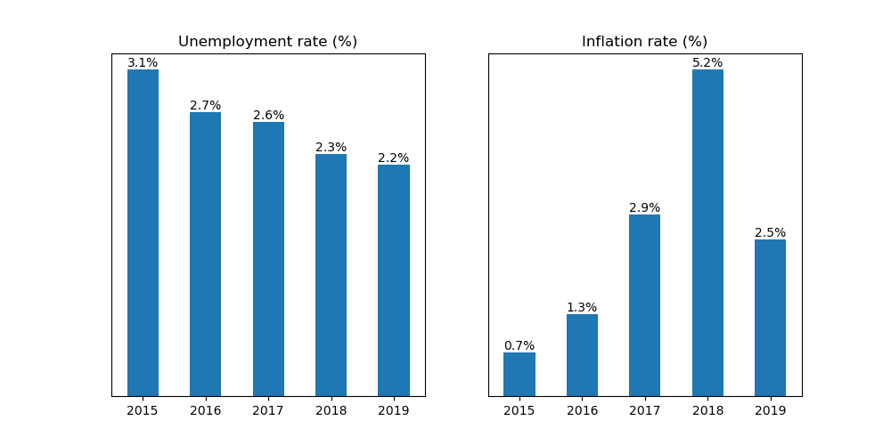

## Current account balance posted a deficit

Current account balance (CAB) recorded a deficit at 0.9% of GDP in 2019. Net trade in goods and services reached USD -36.4 billion. In 2018, CAB posted a deficit at 2.6% of GDP.

USA is the country's top export destination accounting for 16.3% of total exports in 2019. Other major exports partners include Japan (15.1%), China (13.8%), China, Hong Kong SAR (13.6%), and Singapore (5.4%). Top export commodities are electrical machinery and equipment and parts thereof; sound recorders and reproducers; television image and sound recorders and reproducers, parts and accessories of such articles, accounting for 50.5% of total exports.

For imports, top imports origin in 2019 is China (22.8% of total imports), followed by Japan (9.6%), Rep. of Korea (7.5%), USA (7.3%), and Indonesia (6.2%). Major import commodities are electrical machinery and equipment and parts thereof; sound recorders and reproducers; television image and sound recorders and reproducers, parts and accessories of such articles, accounting for 24.2% of total imports.

# Output contracted in Q3 2020

Output plunged by 11.5% year-on-year in Q3 of 2020. Growth in overall economic activity improved from a contraction of 16.8% in the previous quarter. Government expenditure increased by the biggest margin at 5.7% annual growth. On the other hand, the rest of the components, namely gross capital formation, net exports, private consumption, as well as household consumption, contracted by 41.5%, 40.4%, 9.3%, and 9.3%, respectively.

## Consumer confidence down

Meanwhile, consumer confidence index was in the negative territory at -54.5 points in Q3 of 2020. Confidence worsened from nan points in the previous quarter. Expectations of consumers about the general economic situation in the next 12 months turned pessimistic at -4.1 points from nan points over the same period, reflecting improved consumer sentiments.

## Industrial output shrank

Manufacturing shrank by 11.3% year-on-year in October, a decrease from -8.6% growth in the previous month.

## Inflation improved

Overall inflation improved to -1.6% year-on-year in October from -1.4% in the previous month.

Philippines's central bank held unchanged the official policy rate to 1.75% in November from the same in October.

# Outlook tilted downwards this year

On November 2020, Consensus Economics panelists project Philippines's economic growth ending in 2020 at -8.0%. In 2021, the panelists foresee growth at 7.8%. Over the same period, consumption is expected to grow by -7.0% and 7.1%, while investment is projected to grow by -21.4% and 13.9%. Industrial production is seen to grow by -10.4% and 6.3%.

Meanwhile, Consensus Economics panelists foresee inflation averaging in 2020 at 2.4%. In 2021, the panelists project inflation at 2.8%.